CSE 581

**Lab 10: Views**

**Purpose:**

Work with views – create two of them in **CSE581labs** database, extract the data.

**Deliverables:**

Multiple screenshots, as described through the lab.

Scripts that you used to carry out the actions.

**Steps:**

1. Create a view that will display all of the following columns, joining tables (you built in Lab 7 & 8) as appropriate: *Provide a* ***screenshot*** *of script execution.*
2. Student First Name
3. Student Last Name
4. Course Title

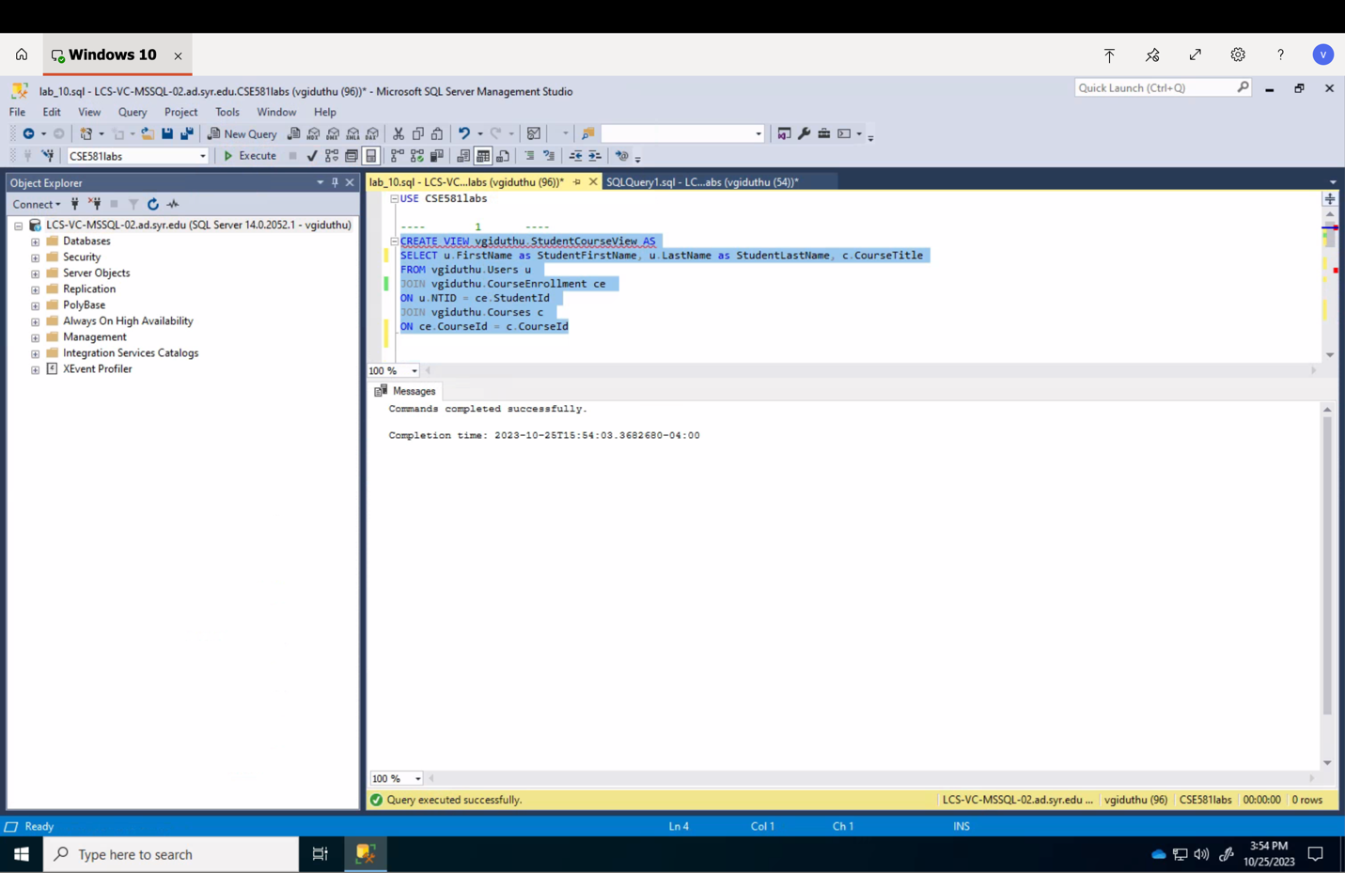

1. Select all data from the view. Provide a **screenshot** of all data[1].

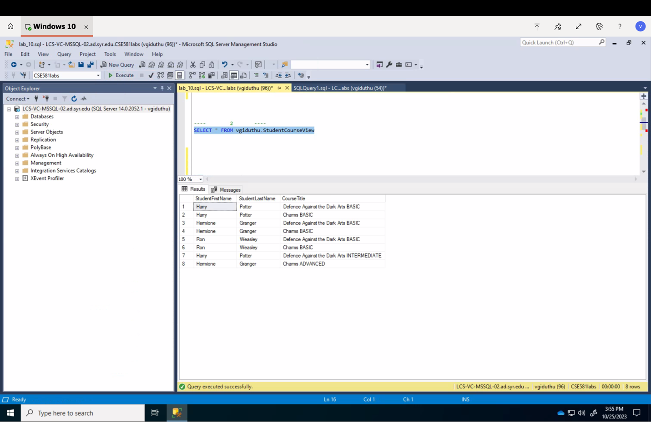

1. Create a view that will display all of the following columns, joining tables (you built in Lab 7 & 8) as appropriate: *Provide a* ***screenshot*** *of script execution.* 
   1. Student First Name
   2. Student Last Name
   3. Course Title
   4. Course Faculty First Name
   5. Course Faculty Last Name
   6. Final Grade (number)

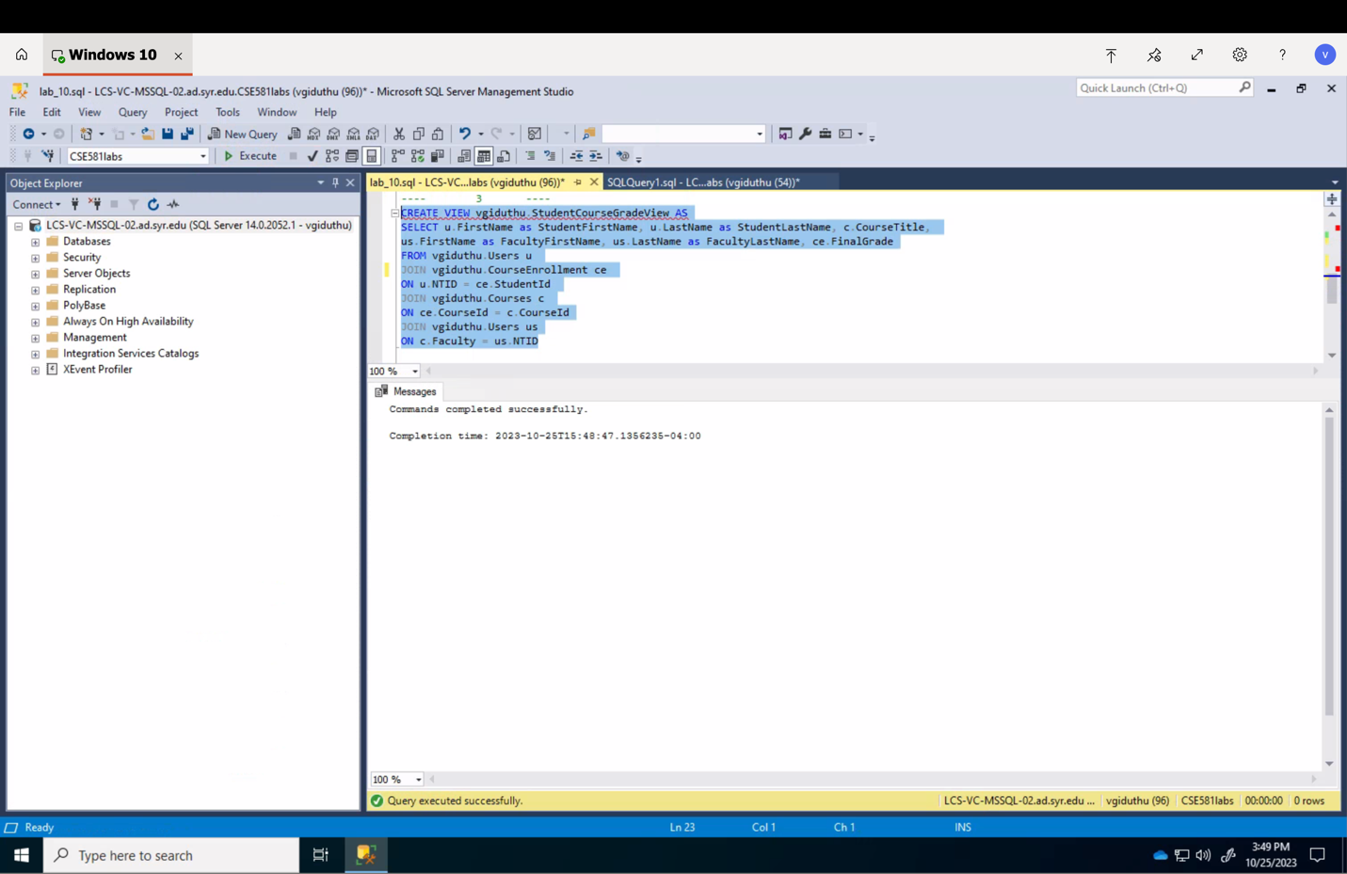

1. Select all data from the 2nd view. Provide a **screenshot**1.

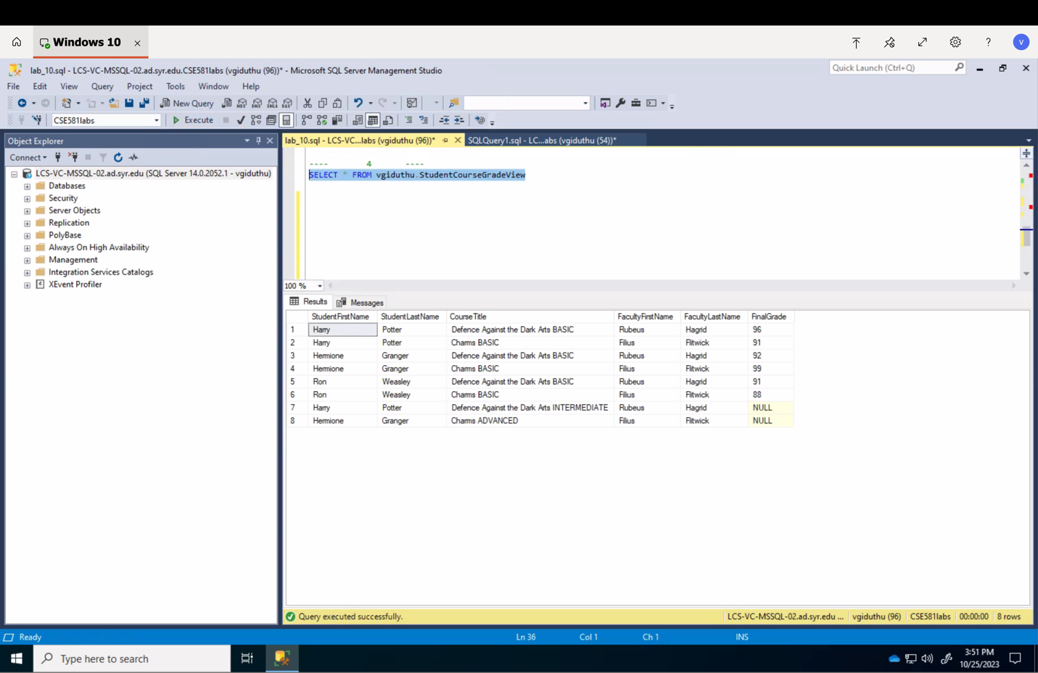

1. Select data from the 2nd view, *for Harry’s classes only*. Provide a **screenshot**1.

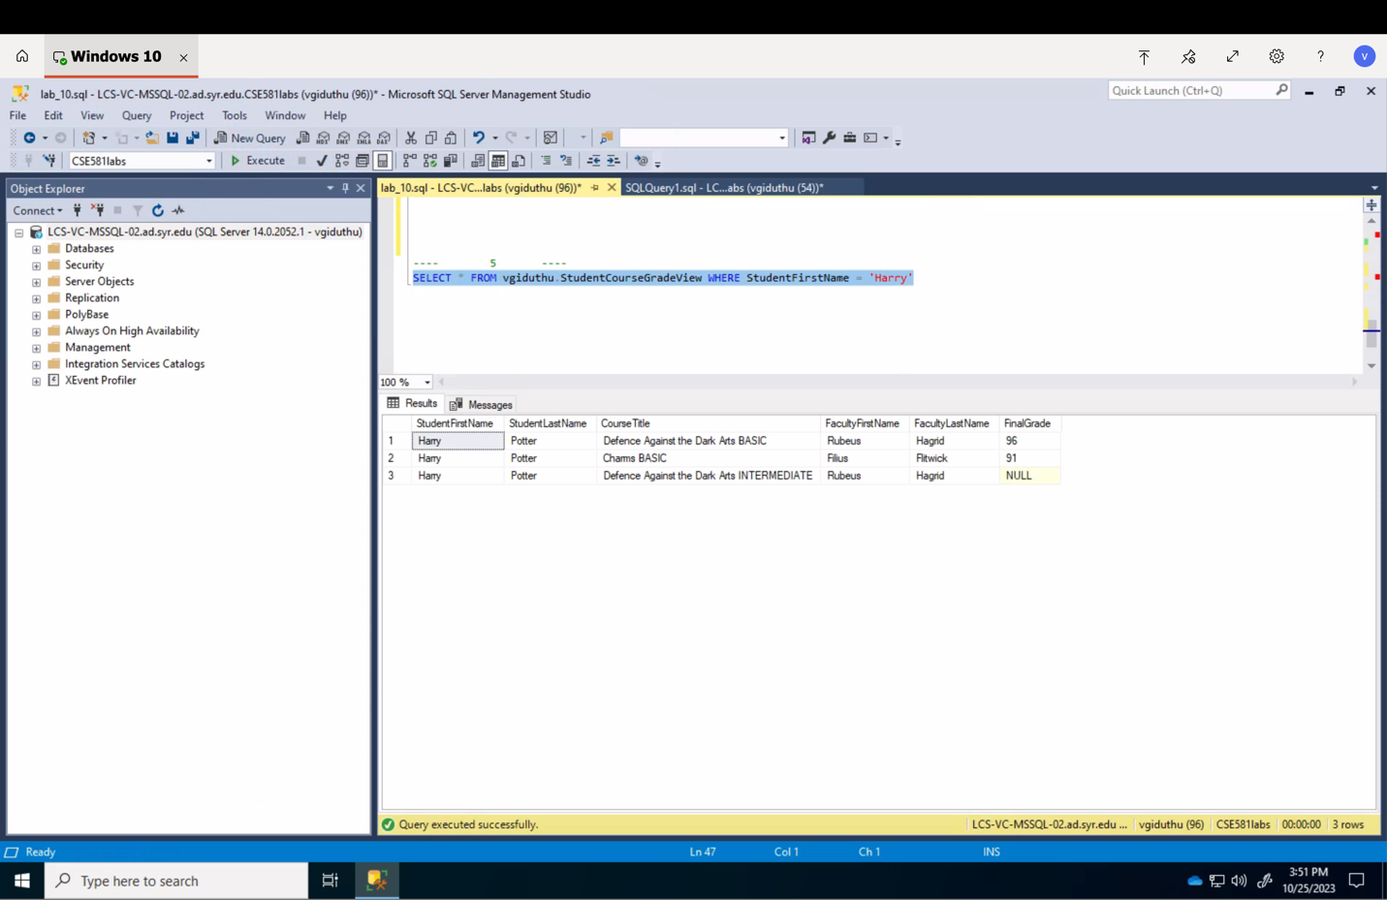

1. You may need to take multiple screenshots, I want to see every single row/column of the selected data.